Inventory Management

# Directions

Complete the simulation found on the Assignment Manager page on the Pearson site and answer the questions below.

To assist with this activity, setup an ExcelOM EOQ template with the Reorder Point box checked. Assume that the company operates 365 days per year.

# Questions

1. How was the initial demand estimated?
2. What were the calculated holding costs?
3. What were the following results?
   1. Total profits
   2. Order accuracy
   3. Unsold inventory due to stockouts
   4. Total number of stock out periods
   5. Number of days without inventory
   6. Excess inventory at the end of the year
4. How was safety stock handled for the simulation?
5. Were the goals reached for the simulation? If not, how could it have been improved? If yes, then what was done that led to the success?

# Overview

## 

## Dashboard

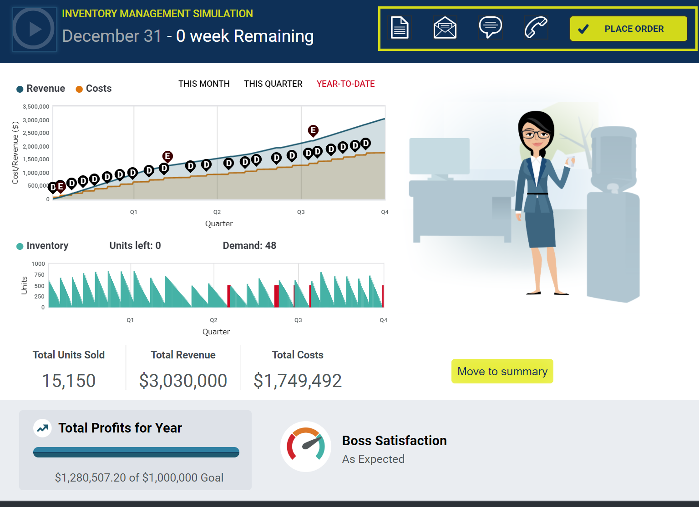

## General Feedback

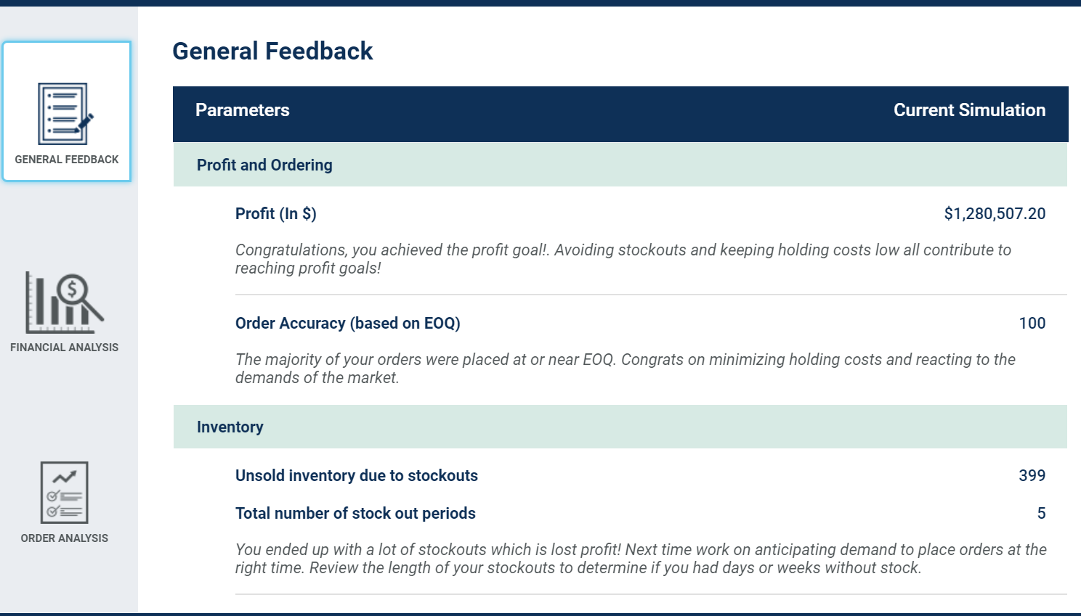



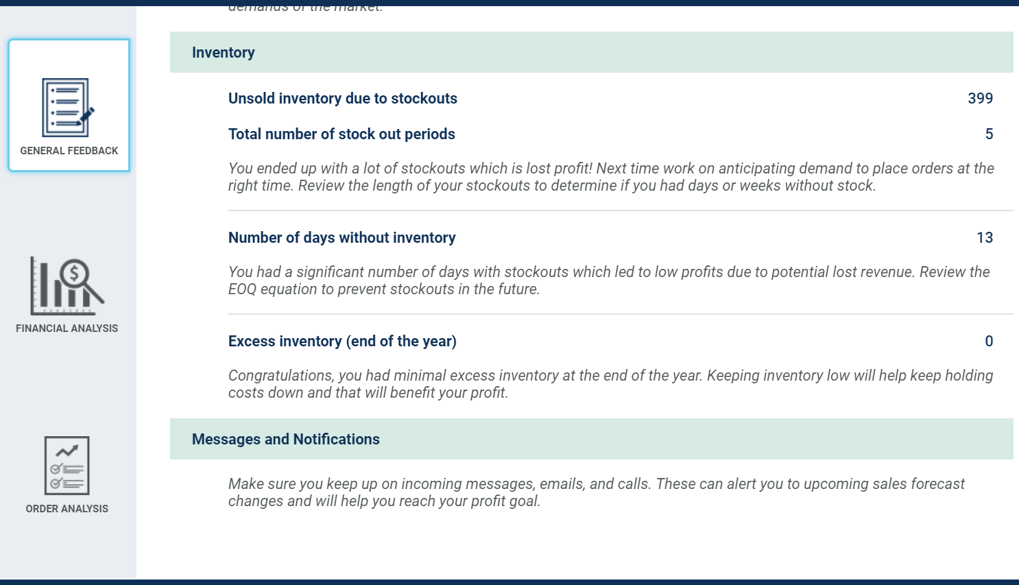

## Financial Analysis

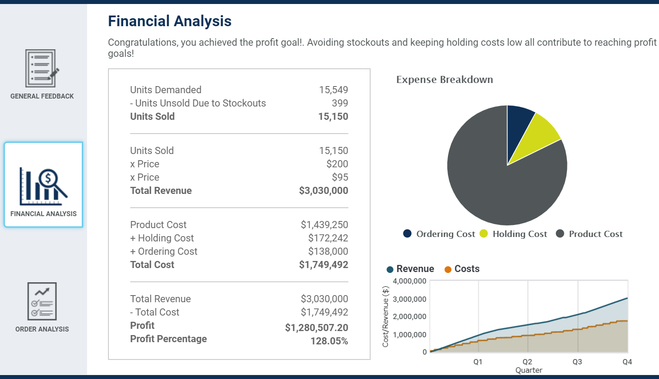

## Order Analysis

